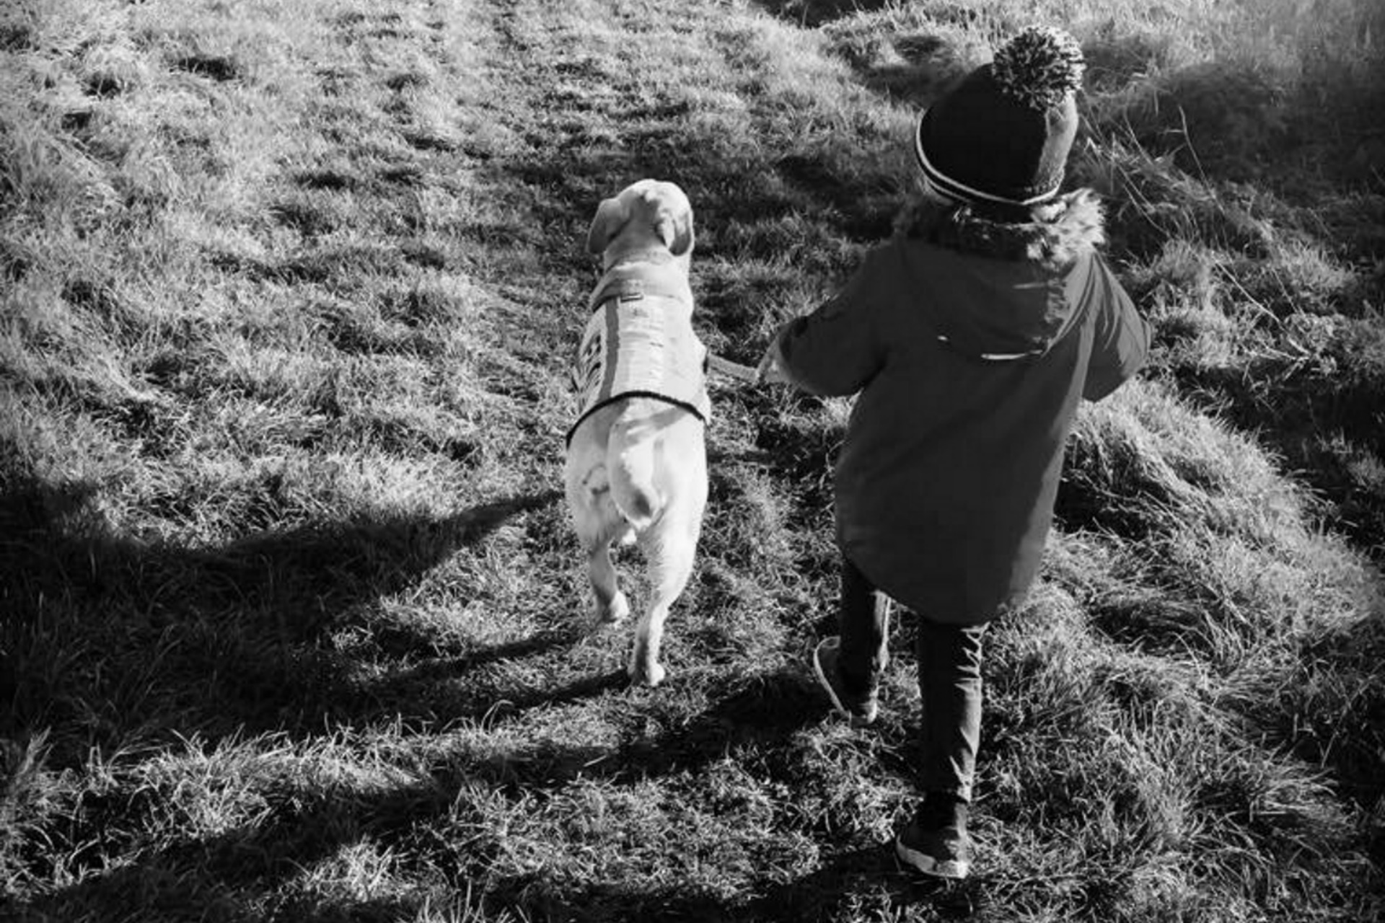

‘Together We Can Achieve’

Behaviour Correction Form
  - External Use Only

Our Approach
Here at Essential Canine Life Skills we pride ourselves in offering a holistic package tailored to you and your dog’s requirements.
We are specialists in supporting all our clients with empathy and with the highest level of quality training. Our awardwinning brand has been recognised by experts on numerous occasions. All our franchise areas are owned by trainers who have had to undergo rigorous assessment and training and we are dedicated to supporting their CPD and wellbeing to ensure you, the client, the best quality of service possible every time.

Positive Reward Based Training

How We Train

Never before has the world seen such a rise in dog owners. Our methods are simple. We use proven fun positive training methods and work hard with our clients to achieve the dog of their dreams. We are passionate about quality customer service and will train you with bespoke holistic packages. We work with you. Harsh outdated training methods are not needed or tolerated.

. Your local trainer wherever you are based will be trained and supported personally in our brand – and you will be supporting the dreams of your local dog trainer. We are also always adding to our online courses to continue to educate more people than ever before. Emma Jane is extremely proud of what has been achieved.

‘Together We Can Achieve’

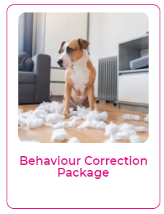 | Behaviour Correction Package  Private 1-2-1 Session for you and your family to assess and advise on your dog’s behaviour in the home. Using our Virtual platform. Due to the everchanging situation with Covid-19 it may be possible for at least one of the sessions to be direct with your trainer. This will be advised to you as time goes on.  Due to the nature of the work, we have limited spaces for this service and will only take a set number of dogs at any one time.  The bundle will start with our full assessment visit as detailed above and then two further one-hour long visits to your home a minimum of three weeks apart.  ​This will give you ongoing support at home to ensure that the training package is suiting your dog needs and requirements. You will also be able to ask questions via our what’s app service as direct support.  As you and your dog progress through the journey, the training plan will need to be tweaked and adjusted.  Price includes written behaviour observation report, training plan and ongoing Whatsapp support.

Thank you for choosing Essential Canine Life Skills and booking onto one of our Behaviour Correction Packages.
As would have been discussed on the phone with you our trainers will work holistically with you to try and resolve the issues that you are having.
Unwanted canine behavior is often a result of underlying problems with dogs, and we always work with in the best interest of the dog. If at any time we feel that we have reached the realms of our experience, then we may recommend referral to a clinical behaviorist. This can be extremely expensive, and it is recommended that before any behaviour adjustment program is started the relevant insurance is taken out and a vet check including blood tests is carried out.
Please find attached a behaviour form for your completion. Please fill this in as carefully and honestly as you can with as much as information as possible, we are not here to judge but need to work with you and your dog openly and honestly.
In cases of aggression, it is a legal requirement for your dog to be muzzled. If you are having issues surrounding contact with people, please advise your trainer and ensure your dog is on lead before they enter the property.

Once the form is completed, please return by email or screen shots to your trainer:
Amanda – amanda@essexdogtraining.co.uk (07976 362782)
Emma – emma@essexdogtraining.co.uk (07742 432441)
Stacey – stacey@essexdogtraining.co.uk (07513 928372)

Once work has commenced no refunds will be given.
In the result of COVID restrictions being put in place in most cases behaviour packages will continue to be direct contact as they are considered welfare issues. However, in the result of national restrictions being put in to place we may suggest pivoting the session online if appropriate or if not deemed appropriate we will “pause” until we are allowed to resume in line with the government guidelines.
Some dogs that we work with will benefit from weekly classes but are not suited to direct trainer classes. We operate an online class for these dogs on a Thursday at 8.15pm, your dog will benefit no end with these sessions so please discuss with your trainer.
We look forward to working with you and your dog.
Kind regards

Client Name

Address

Telephone Number

Email Address

Date & Time of 1st Appt

Name of Dog

Age of Dog

Breed of Dog

Brief history of Dog

Please give a description of the behaviour issues that you are currently experiencing and would like to address

Have you had a previous visit with any other trainer to address this issue– please give full details of any classes attended or any method used

How long has this behaviour been going on for?

Are you aware of any triggers?
Has your dog bitten and if so, please give full details inc whether bite has broken skin?
Please give full details of any other animals in the house

Please give details of the amount of people in the house
Please give details of a typical weekly routine for your dog

What is your dog fed on? Please give full details including any treats and chews? Including any medication

How much daily exercise does your dog receive?
How much daily mental stimulation does your dog have?
What training have you done with your dog?

Is your dog on any medication?

Does your dog have any medical issues?

Who will be present at the behaviour visit?

What is your main goal for this behaviour package?

FOR OFFICE USE ONLY

Deposit Received by which method
New/Existing
Assessment details inside

Assessment details outside

Behaviour Plan

Follow Up
Follow Up
Follow Up
Follow Up
Follow Up
Date Signed Off
Payment Received

