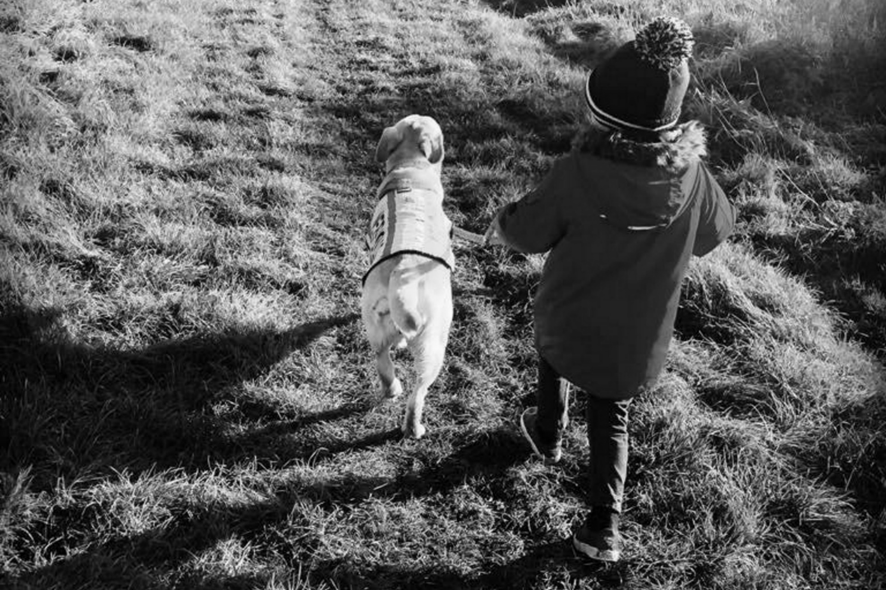

‘Together We Can Achieve’

Covid-19 Indoor Facilities Risk Assessment
Essential Canine Life Skills COVID-19 Risk Assessment for indoor training
Area of Risk | Risk identified | Actions to take to mitigate  risk | Notes
Cleanliness of hall and  equipment, especially after  other hires | Other hirers or hall cleaner  have not cleaned hall or  equipment used to standard  required. Our group leaves hall  or equipment without cleaning. | Make sure our group cleans used  surfaces before and after hire e.g.  tables, sinks, door and toilet  handles – if used – where possible don’t use. | Bring own cleaning products and use gloves to clean
Managing Social distancing  and especially people  attending who may be  vulnerable | People do not maintain 2 m  social distancing  People do not wear masks, and  are not exempt. | Advise group they must comply with social distancing as far as possible. Adopt layout advised ie 6 pods. Entry and exit into hall with masks on only.  Limit numbers using toilets at  Once, only one cubicle to be made available  Have one way in, one way out system of entry an exit. | Where possible train outside in garden areas. And No access to anyone other than staff to common areas.  Allow people time to use toilets  without others present.
Respiratory hygiene | Transmission to other  members of group | Catch It, Bin It, Kill It. Encourage group to avoid touching mouth,eyes, and nose.  No interaction between members or dogs  To maintain air flow in hall to open doors where possible & open windows | Remember to bring  hand sanitiser.  Remember to remind people to take their own rubbish home.  Open windows/doors if indoors
Hand cleanliness | Transmission to other  members of group and  premises | Advise group to use sanitiser on  entering and exiting the hall, to  wash hands extensively using soap and paper towels.  Sinks in toilet will be available at all times  Doors/windows will be open/closed by staff only. | Make sanitiser available at entrance
Someone falls ill with  COVID-19 symptoms | Transmission to other  members of group and  premises | Follow hall instructions. Move  person to safe area, obtain  contacts, inform hall manager. | Track and trace in place. All attendees are traceable.
Last amendment 3/10/2020 – agreed Emma Jane Frost

